**Isekai Ecommerce Store**

Isekai Store is an E-Commerce website having all the important features. Customers will be able to buy computers, laptops and anything they desire at this website. Website is user-friendly interface, quick response times which will result in having good experience with customers

Having the CRUD operations implanted in it, as well as Facebook Chat, and using ajax in the creating of the site as well as outsourcing to create or generate a pdf document from the invoices , this site is a representation of everything we have been taught through our journey in Axsos academy. So let us take you step by step through our Isekai Site.

Using the log in and registration users who are new can easily register their account and proceed to the site

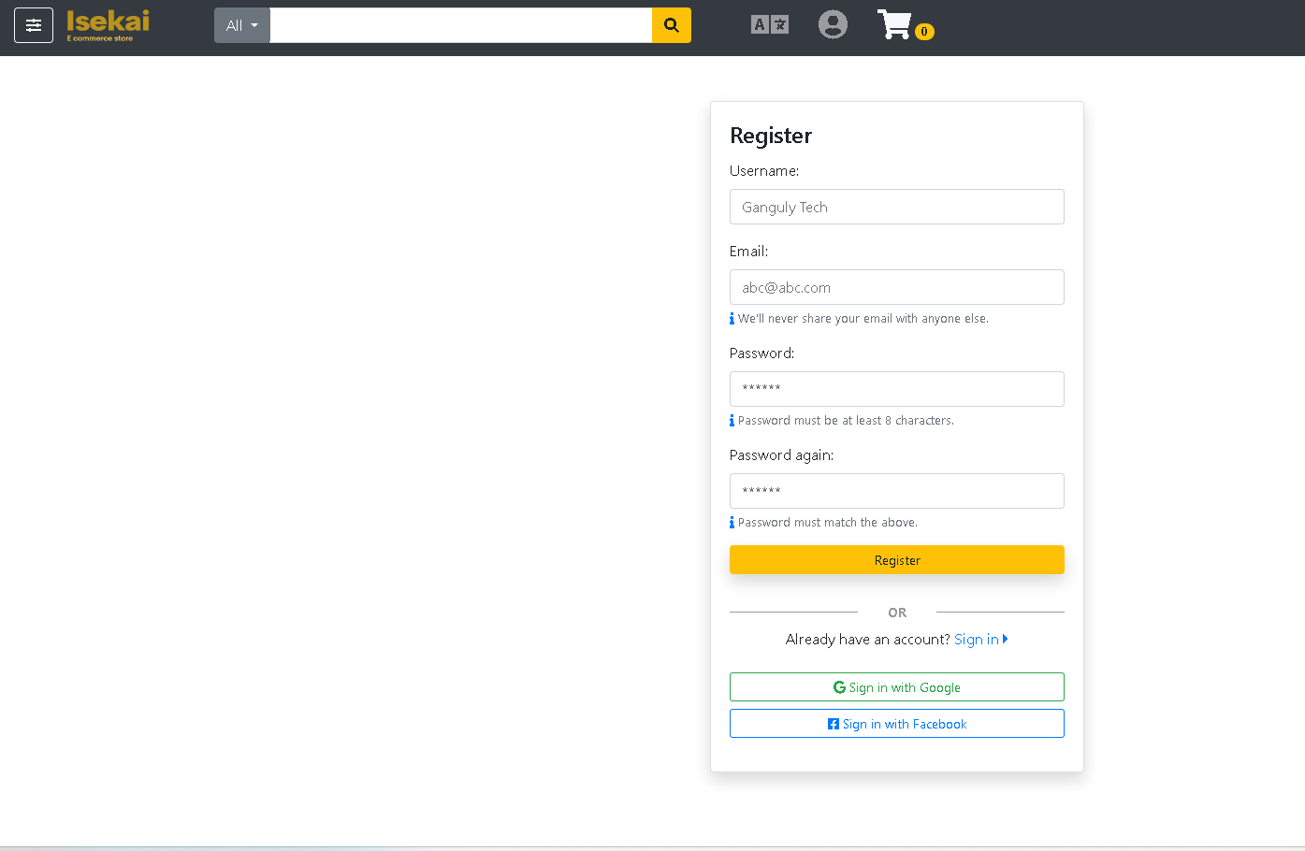

However, validation is added for logging in and registration meaning the password should match and meet

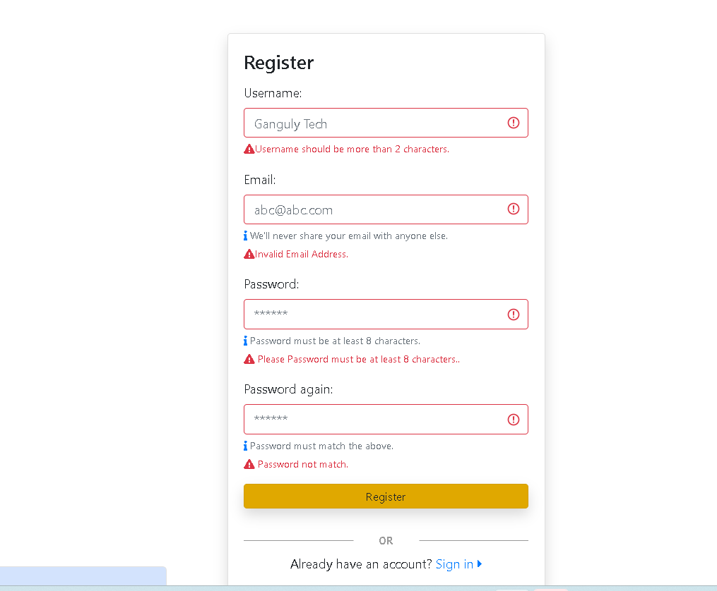

Once the user is logged on or registered, they can then navigate through the Site

Using the main page of the website or the Dashboard consist of items that can be viewed and if chooses the user can add them to the cart and when pressing on the menu you can view several options such as settings which has a log out option to exit your account and the site at once, as well as Your account button which has some of your personal details

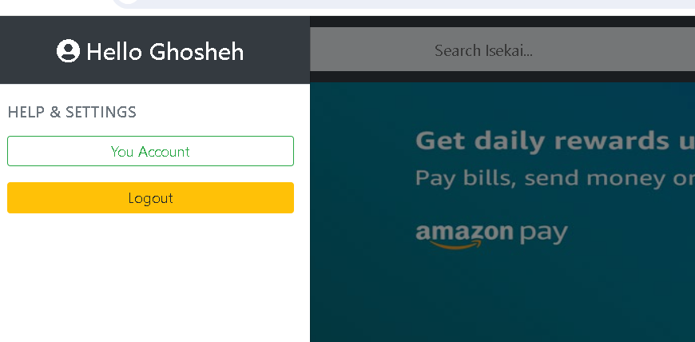

Pressing your account button would navigate you to a new page that has three options laid out for the user

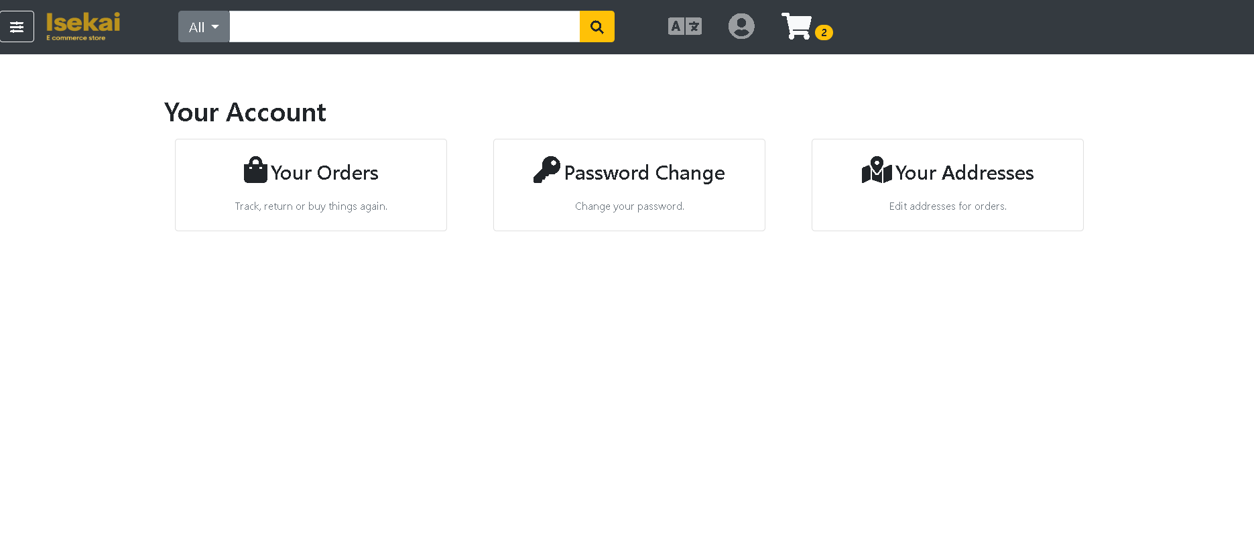

Your orders which has all the orders you have made through using this website weather its today or five years ago all the data would be there and it will be shown how briefly, we have the password change where user can change there password and it as well have validation meaning the user cant enter and incorrect or invalid email and old passwords and they should match as well

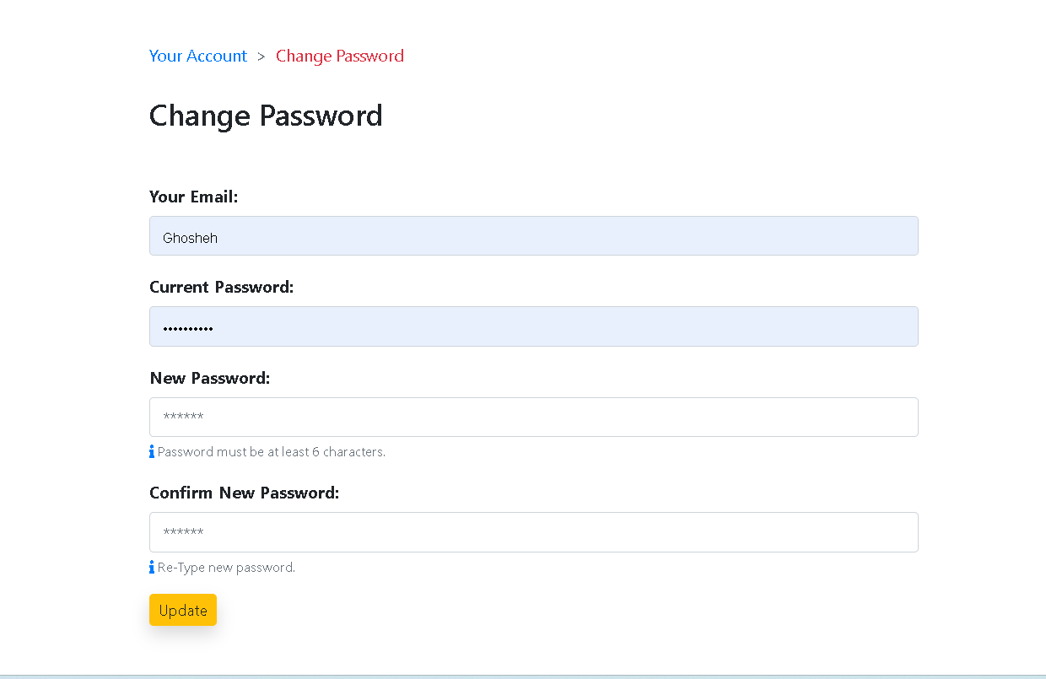going back to users account page we have the address the address is where the items in the cart are going to be shipped at

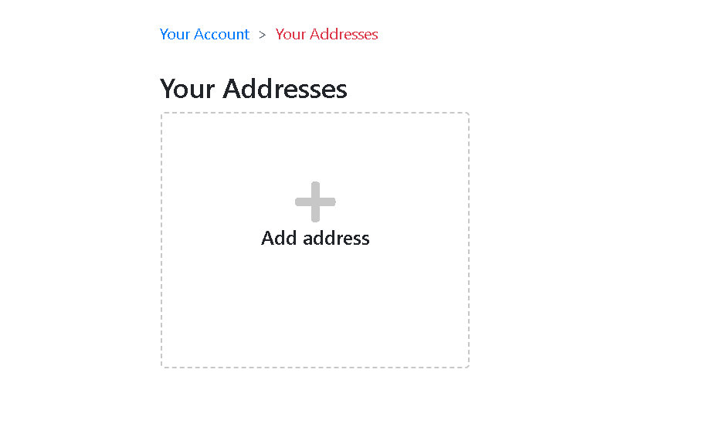

Adding an address would require country and region, name and other details that are important to anyone who want to buy something and have it specificily ordered to a location it has a validation as well and the user can add more than one address

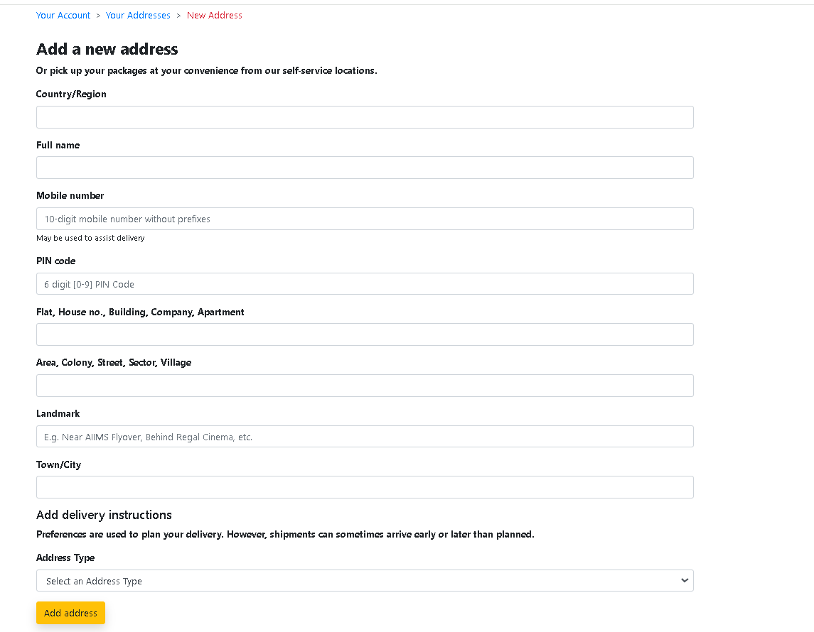

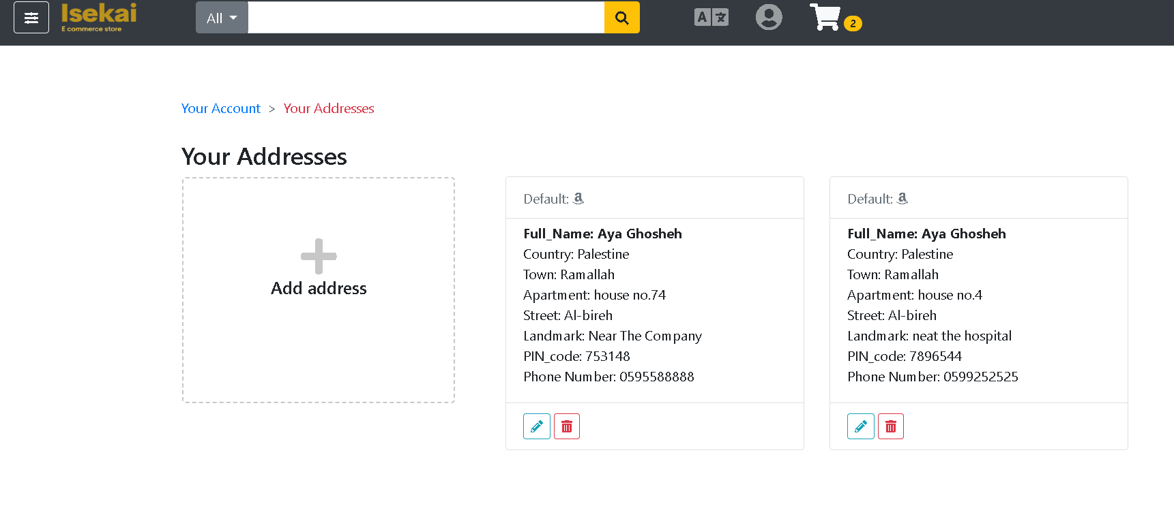

going back to the items displayed in the main page our view is like this the user can see all the items displayed in the main page and view them as desired and there is a search bar that is full functioning with Ajax that display the items of the search in a drop down manner.

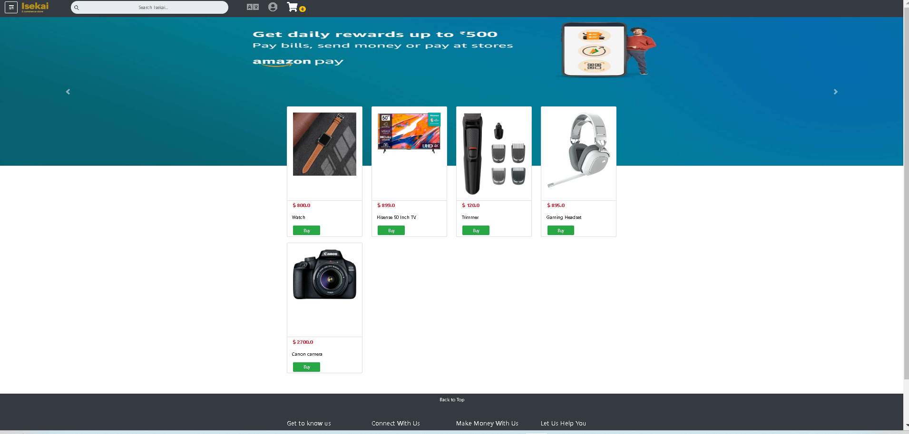

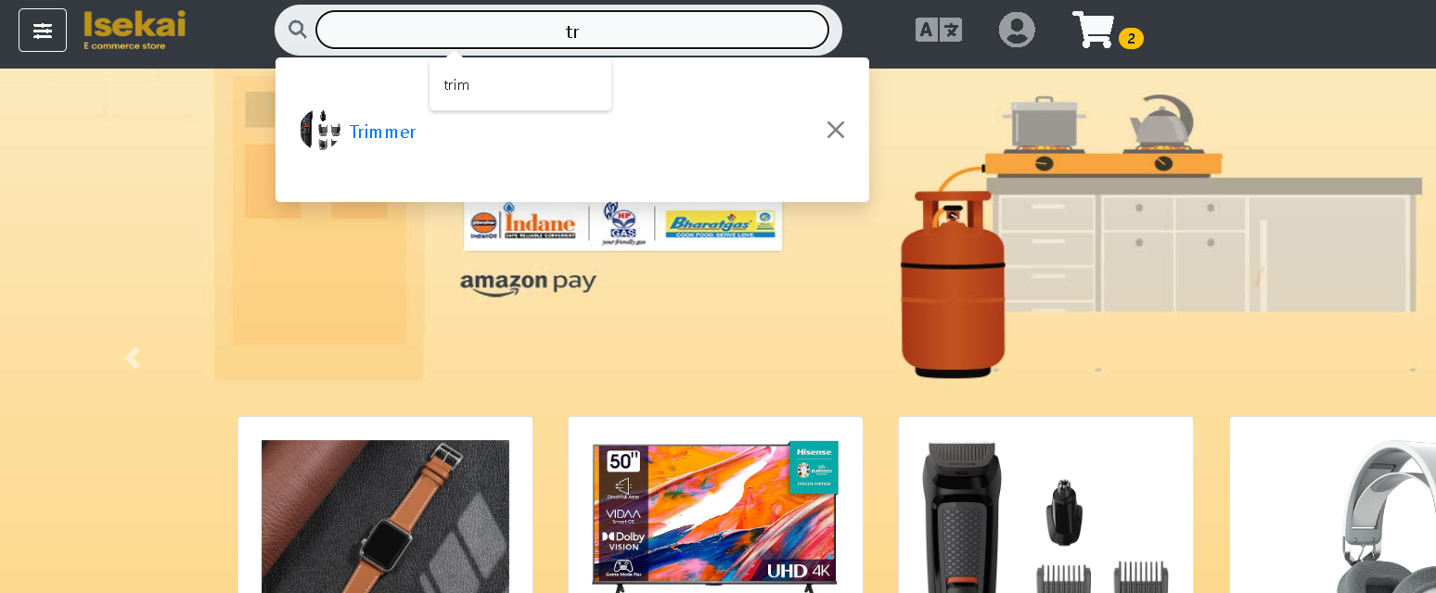

Viewing a specific item and adding it to the cart with a targeted quantity as well can be done through viewing the item:

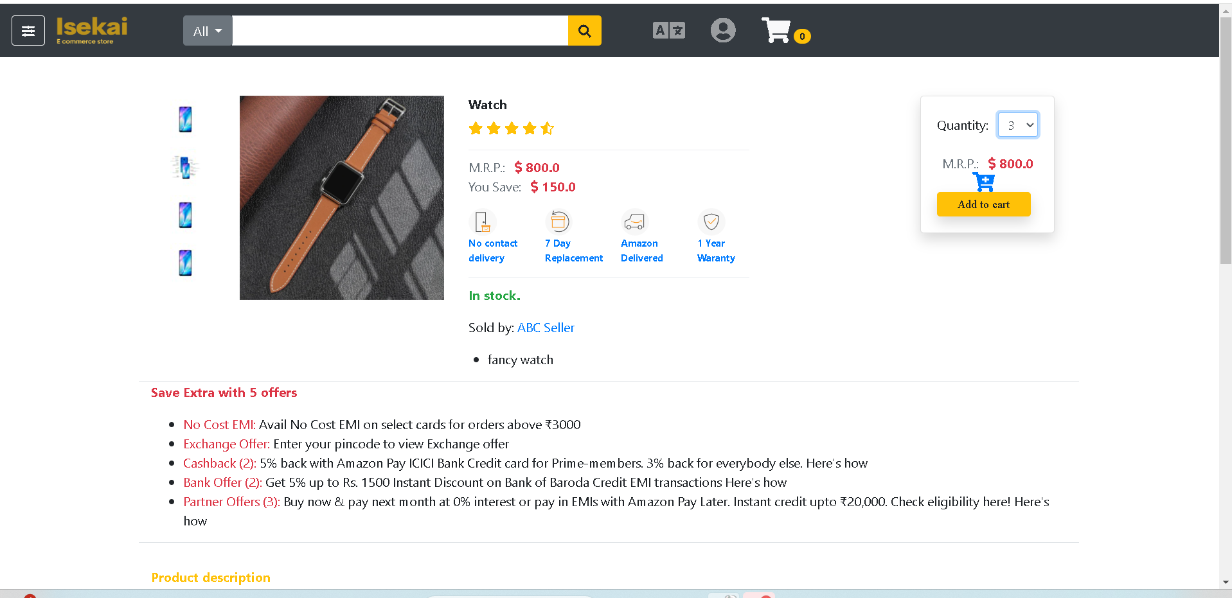

When adding it goes to the cart and of course you can add multiple items it shows how much of itmes it has on the navigation bar next to the icon of the cart of how many items the cart has when pressing on the cart items are displayed in this manner as well as the sum of the items inside it

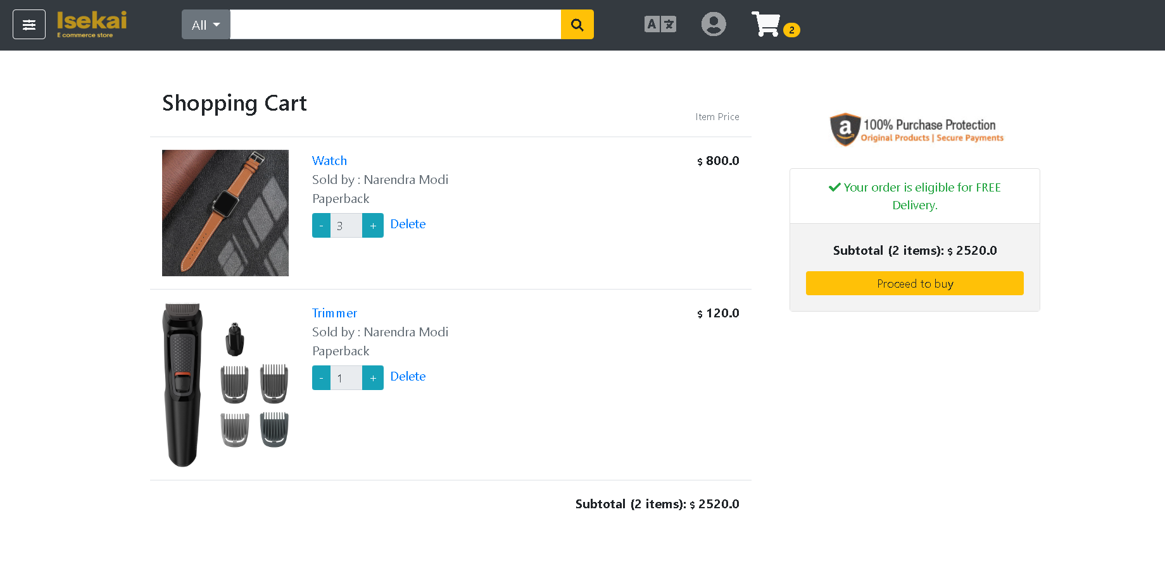

Proceeding to buy button would take the user to the address and payment method

Giving the user the ability to choose which address if they have entered more than one previously in their account

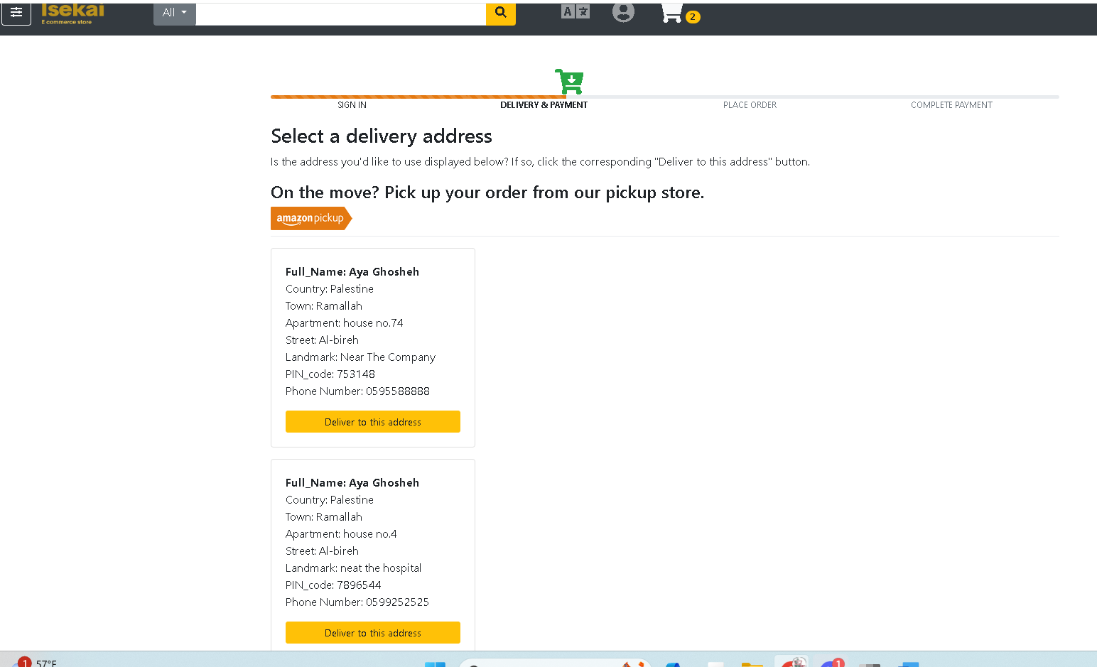

Once the address is chosen the payment method would be chosen as well  
  
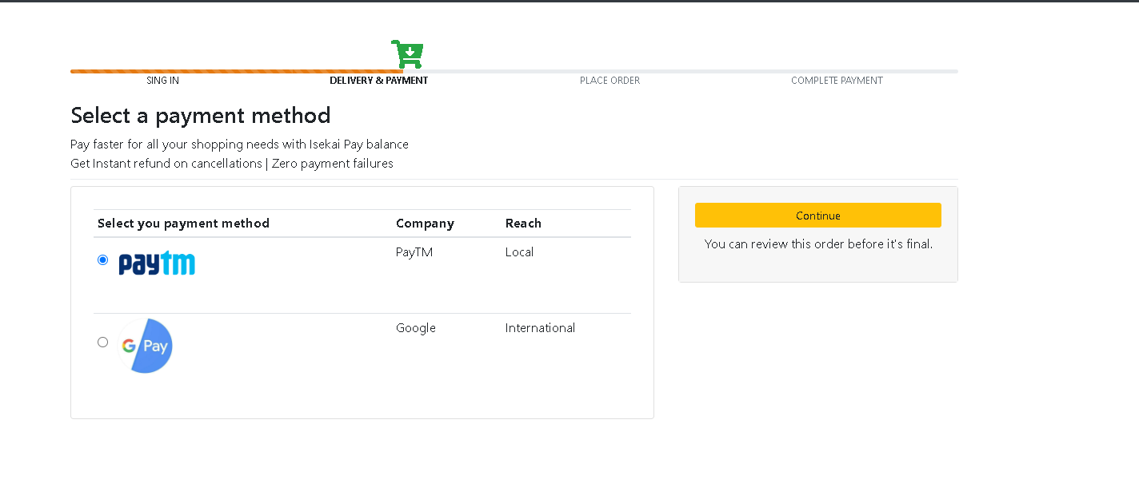

After pressing continue you would be able to view the items all in a summery form

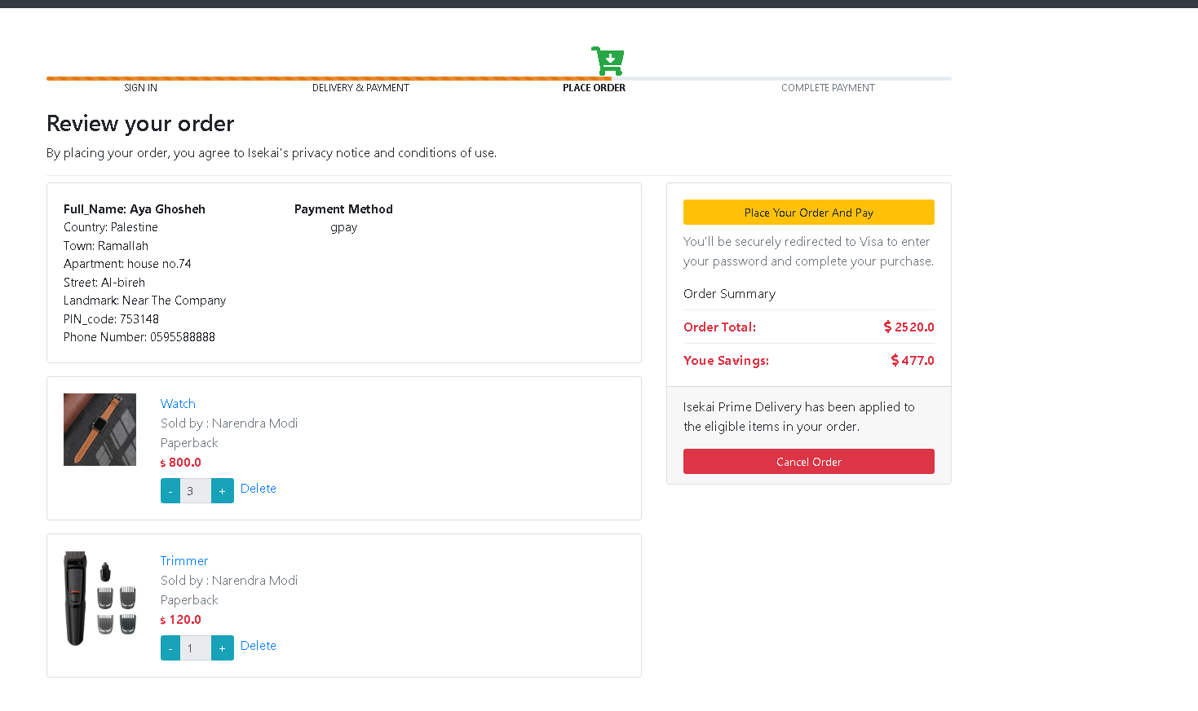

This would help the user to review everything once more before canceling the order if they don’t want a specific item or just want to not buy anything any more or can take them to the payment method

By pressing place your order, the viewer would be having to full the payment requested data

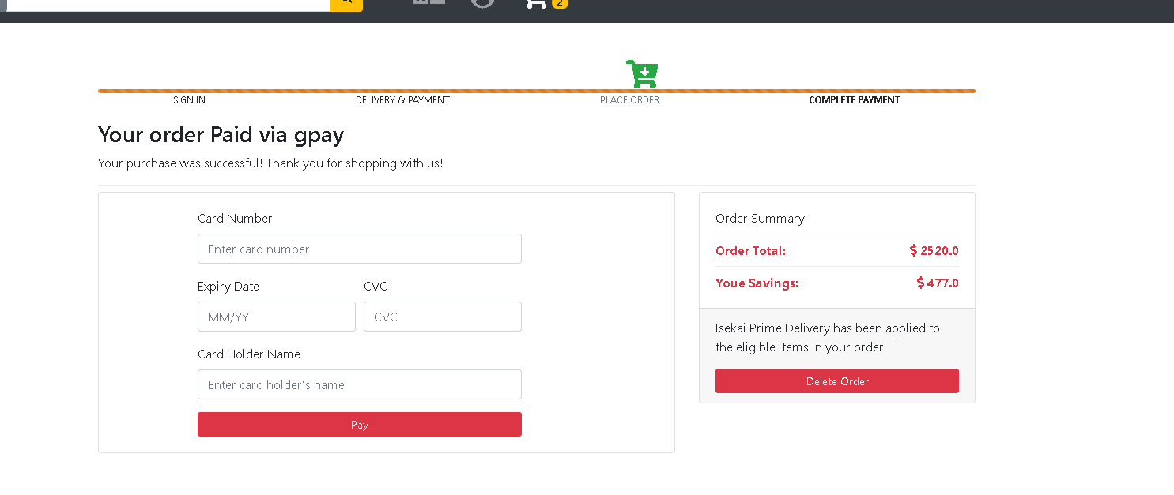

As mentioned before everything has a validation the card number must be at least 16 numbers the date 5 and the cvc 3 and so on as you can see the chosen method of payment previously chosen is displayed here and then when the user fill out the information the cart would be emptied out and a pdf would be downloaded to the users profile containing all the necessary data from items to address to payment that can be saved into the user account however assuming the user has misplaced it they can go to the account and see what they have previously bought and of course if the user choses they can delete the order before it s paid for.

Processing the payment would display this   
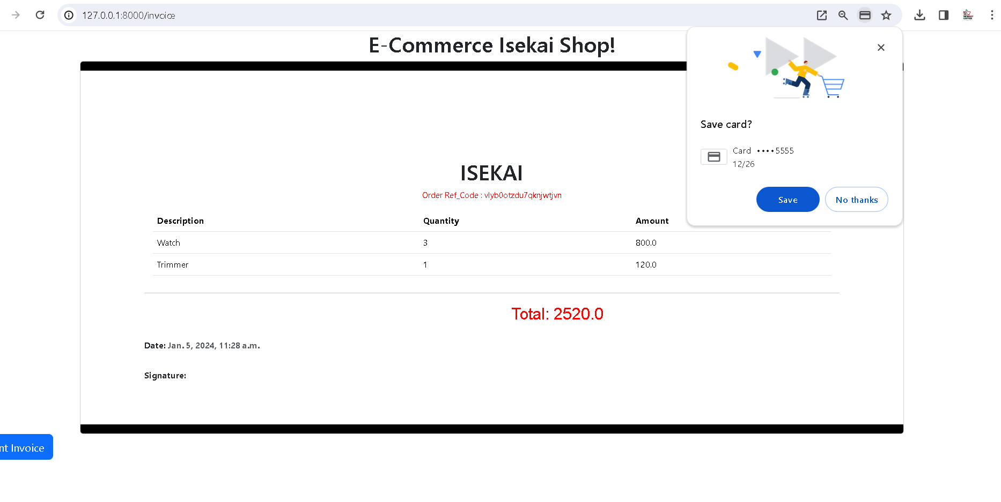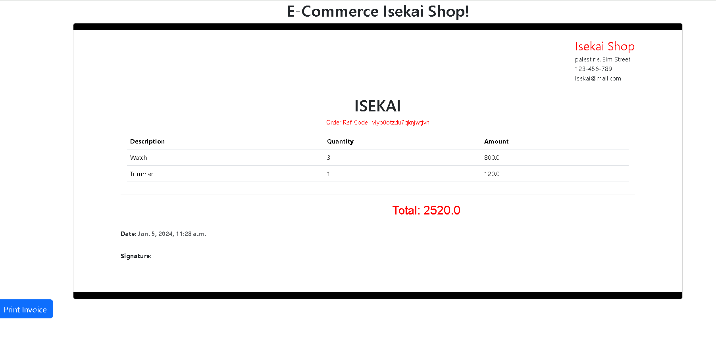print out your invoice would let the user have the invoice printed or saved as a pdf as previously mentioned:  
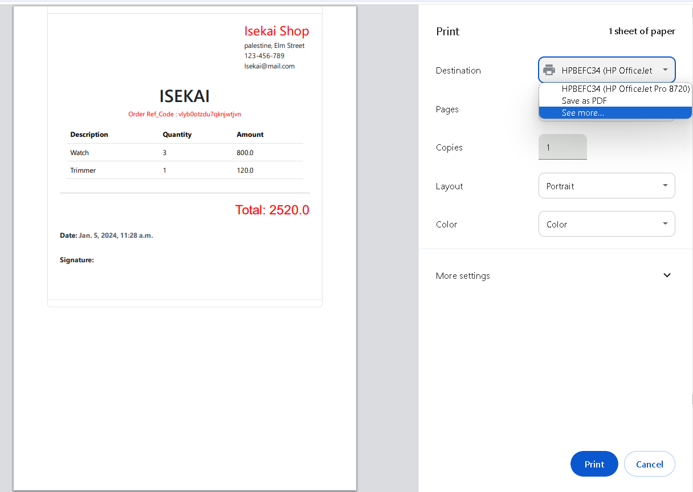

Going back to the main page the user would have an empty cart and is ready to buy

As previously mentioned, if the user wants to see the order again and they misplaced the invoice they can go to account and just view it from

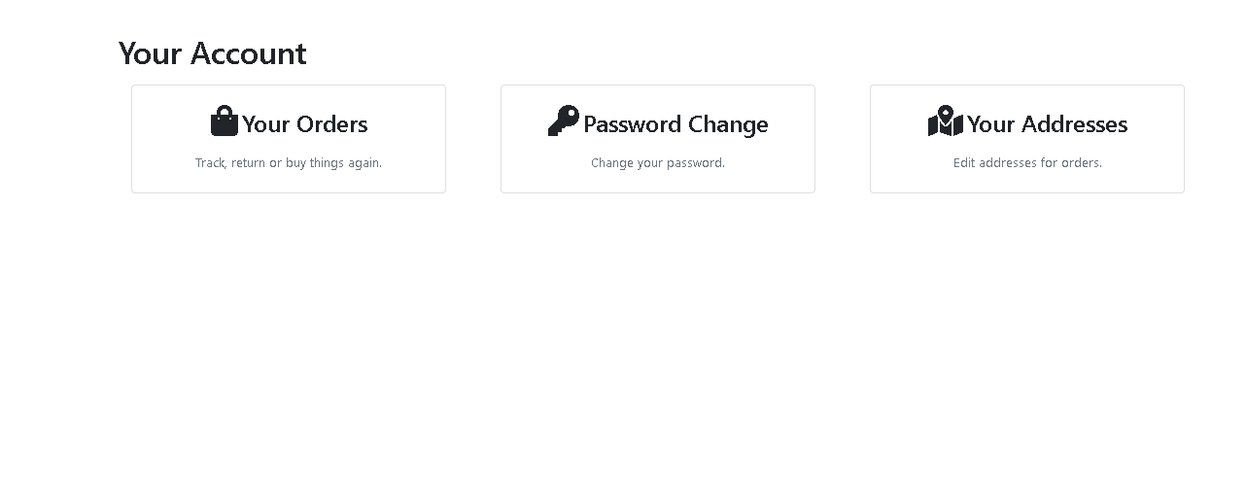your orders and it will be shown as followed:

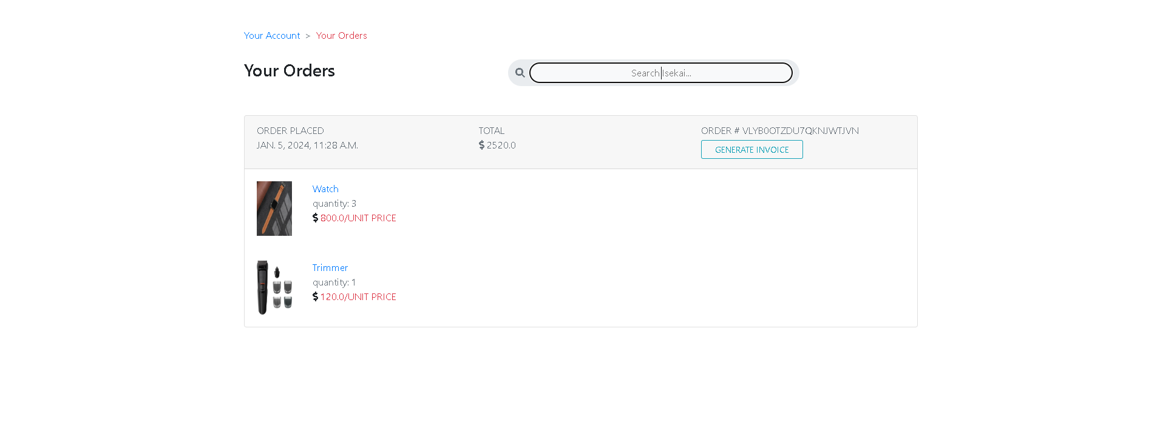

They can even regenerate the invoice again by pressing on the Generate invoice ,

And of course if we have any complaints or anything you need we have a facebook Chat box that can be replied and talked to as the user please

